My Spending Diary | 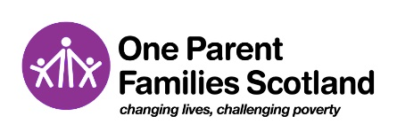
A spending diary is a great way to keep on track of where your money goes. It can help you to see where you are overspending and where you may be able to make cutbacks. Your expenses will generally come under one of three categories, detailed below. What is essential for one person may not be for another but have a think about whether everything you spend is truly a need rather than a want.

Essential fixed bills: regular bills you must pay each week or month such as:
Rent/Mortgage | Council tax | Water | Gas & electricity | Travel costs | Health costs | Phone & internet

Essential flexible bills: regular expenses on things you need such as:
Food | Clothing | Hairdressing

Non-essential spending: all other expenses you may have such as:
Cigarettes | Cinema | Snacks | Soft play | Night out

Instructions for use
Fill in the spending diary every day for a whole month. You can either fill this in as you go along, or take some time at the end of each day to update what you've spent that day. Don't forget to look at your bank account and write down any Direct Debit or standing order payments that have come out each day. Make sure you write down everything you have spent that day, even if it's just a few pence on a newspaper or sweets for the kids.
DATE | What did I buy/pay for? | Essential Fixed Bills  How much? | Essential Flexible Bills How much? | Non-Essential Spending How much?

Call the Lone Parent Helpline on - 0808 801 0323

© One Parent Families Scotland, a charitable company limited by guarantee.

Registered at Edinburgh under number 094860. Scottish Charity Number SC006403.

